***Assignment 9***

1.Odd String Difference

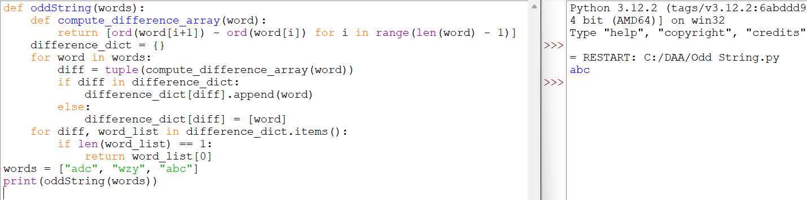

2. Words Within Two Edits of Dictionary

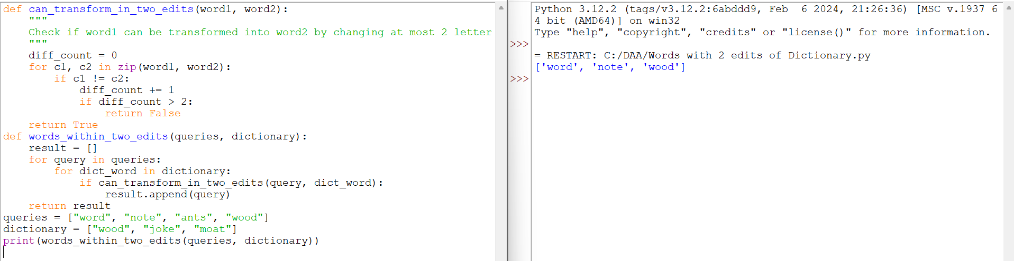

3. Destroy Sequential Targets

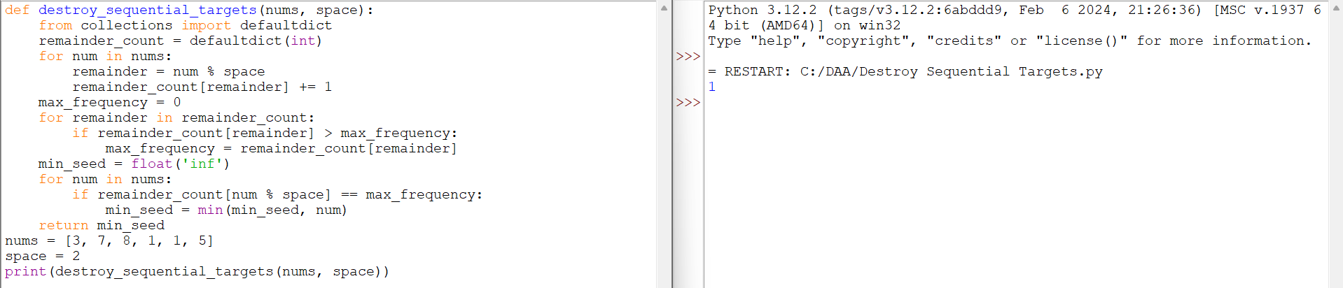

4. Next Greater Element IV

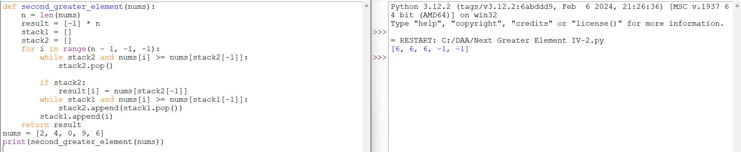

5. Average Value of Even Numbers That Are Divisible by Three

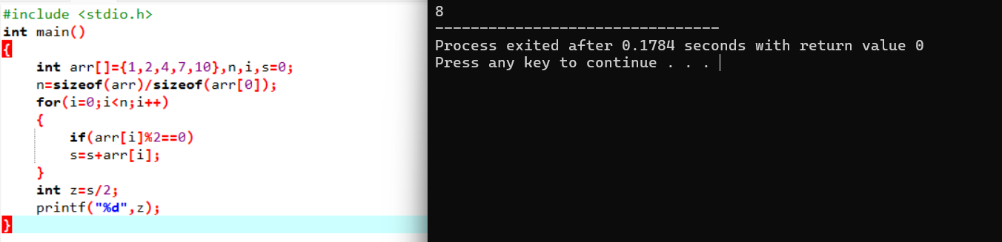

6. Most Popular Video Creator

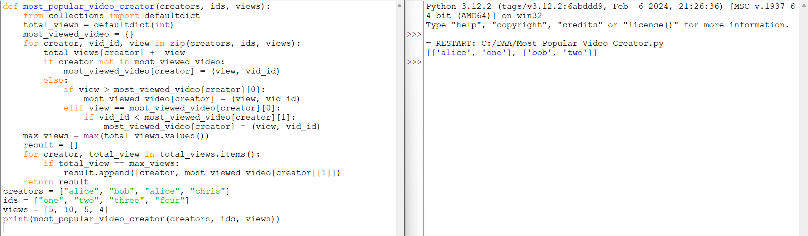

7. Minimum Addition to Make Integer Beautiful

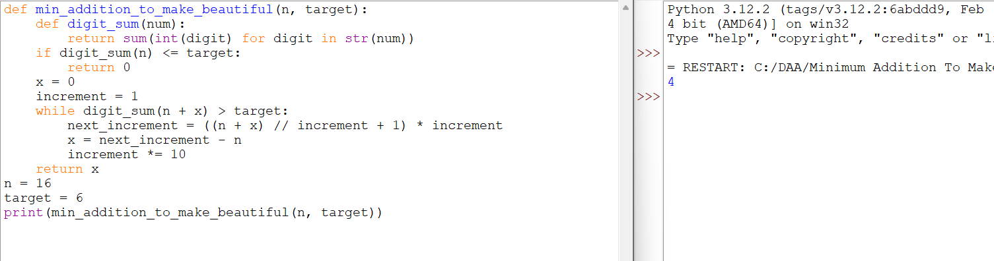

8. Split Message Based on Limit